Aim:
- To implement Linear Regression on the Housing dataset to predict house prices.
- To implement Logistic Regression on the same dataset to classify houses into High Price and Low Price categories.
- To evaluate and compare the performance of both models using performance matrices.

Theory:

Linear Regression:
- Linear Regression is a supervised machine learning algorithm used for predicting a continuous dependent variable based on one or more independent variables.
- The relationship between input X and output y is modeled as a linear equation:
- Performance Metrics:
  - MSE (Mean Squared Error): Average squared difference between predicted and actual values.
  - MAE (Mean Absolute Error): Average absolute difference between predicted and actual values.
  - R² Score: Measures goodness of fit; ranges from 0 to 1.

Logistic Regression:
- Logistic Regression is a supervised classification algorithm used when the output is categorical (binary 0/1).
- Uses the sigmoid function to map predictions between 0 and 1:
σ(x)=11+e−x\sigma(x) = \frac{1}{1+e^{-x}}σ(x)=1+e−x1​
- Performance Metrics:
  - Confusion Matrix: Shows True Positive (TP), True Negative (TN), False Positive (FP), False Negative (FN)
  - Accuracy, Precision, Recall, F1-Score

Tools/Software Required:
- Python 3.x
- Libraries: pandas, numpy, matplotlib, scikit-learn

Procedure:

Step 1: Load Dataset
- Read Housing.csv using pandas.
- Check the first few rows to verify the data.
data = pd.read_csv("Housing.csv")
print(data.head())

Step 2: Linear Regression
- Select input feature: area.
- Select target variable: price.
- Split dataset into training and testing (80:20).
- Train LinearRegression model.
- Predict prices for test set.
- Compute performance metrics: MSE, MAE, R².
- Plot scatter + regression line.

Step 3: Logistic Regression
- Convert price into binary category based on median price:
  - High Price (>= median) = 1
  - Low Price (< median) = 0
- Select input feature: area.
- Select target: price_category.
- Split dataset into training and testing (80:20).
- Train LogisticRegression model.
- Predict class labels for test set.
- Compute confusion matrix and performance metrics: Accuracy, Precision, Recall, F1.
- Plot sigmoid probability curve.

Step 4: Visualize Results
- Linear Regression: scatter plot of actual vs predicted prices with regression line.
- Logistic Regression: scatter plot of actual classes with predicted probability (sigmoid curve).

Dataset:
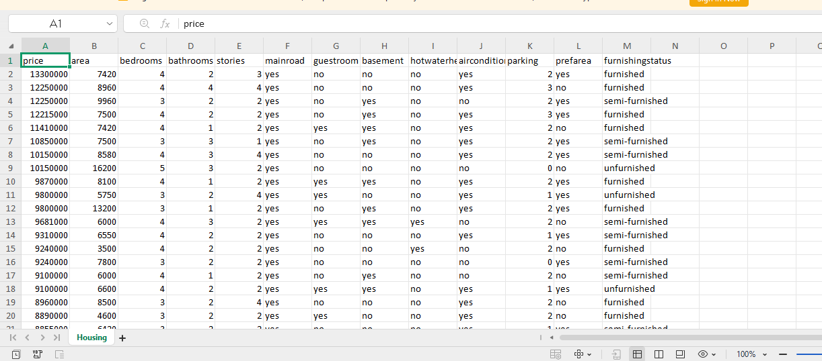
# ====================================================
# HOUSING REGRESSION PERFORMANCE MATRICES
# LINEAR & LOGISTIC REGRESSION
# ====================================================

# -------- IMPORT LIBRARIES --------
import pandas as pd
import numpy as np

from sklearn.model_selection import train_test_split
from sklearn.linear_model import LinearRegression, LogisticRegression
from sklearn.metrics import (
mean_squared_error,
mean_absolute_error,
r2_score,
confusion_matrix,
accuracy_score,
precision_score,
recall_score,
f1_score
)
code:

# -------- LOAD DATASET --------
data = pd.read_csv("Housing.csv")
print("Dataset Preview:")
print(data.head())

# ====================================================
# PART 1: LINEAR REGRESSION
# ====================================================
print("\n================ LINEAR REGRESSION =================")

# Feature and target
X_lr = data[['area']]
y_lr = data['price']

# Split data
X_train_lr, X_test_lr, y_train_lr, y_test_lr = train_test_split(
X_lr, y_lr, test_size=0.2, random_state=42
)

# Train model
lr_model = LinearRegression()
lr_model.fit(X_train_lr, y_train_lr)

# Predict
y_pred_lr = lr_model.predict(X_test_lr)

# ---- PERFORMANCE MATRIX (Regression) ----
linear_performance_matrix = pd.DataFrame({
"Metric": ["Mean Squared Error", "Mean Absolute Error", "R2 Score"],
"Value": [
mean_squared_error(y_test_lr, y_pred_lr),
mean_absolute_error(y_test_lr, y_pred_lr),
r2_score(y_test_lr, y_pred_lr)
]
})

print("\nLinear Regression Performance Matrix:")
print(linear_performance_matrix)

# ====================================================
# PART 2: LOGISTIC REGRESSION
# ====================================================
print("\n================ LOGISTIC REGRESSION =================")

# Create binary target using median price
median_price = data['price'].median()
data['price_category'] = (data['price'] >= median_price).astype(int)

# Feature and target
X_log = data[['area']]
y_log = data['price_category']

# Split data
X_train_log, X_test_log, y_train_log, y_test_log = train_test_split(
X_log, y_log, test_size=0.2, random_state=42
)

# Train model
log_model = LogisticRegression()
log_model.fit(X_train_log, y_train_log)

# Predict
y_pred_log = log_model.predict(X_test_log)

# ---- CONFUSION MATRIX ----
conf_matrix_log = confusion_matrix(y_test_log, y_pred_log)
conf_matrix_log_df = pd.DataFrame(
conf_matrix_log,
columns=["Predicted Low (0)", "Predicted High (1)"],
index=["Actual Low (0)", "Actual High (1)"]
)

# ---- PERFORMANCE METRICS ----
accuracy = accuracy_score(y_test_log, y_pred_log)
precision = precision_score(y_test_log, y_pred_log)
recall = recall_score(y_test_log, y_pred_log)
f1 = f1_score(y_test_log, y_pred_log)

logistic_performance_matrix = pd.DataFrame({
"Metric": ["Accuracy", "Precision (High Price)", "Recall (High Price)", "F1 Score (High Price)"],
"Value": [accuracy, precision, recall, f1]
})

print("\nLogistic Regression Confusion Matrix:")
print(conf_matrix_log_df)

print("\nLogistic Regression Performance Matrix:")
print(logistic_performance_matrix)

# ====================================================
# OPTIONAL: VISUALIZATION
# ====================================================
import matplotlib.pyplot as plt

# Linear Regression Graph
plt.figure()
plt.scatter(X_test_lr, y_test_lr, label="Actual Price")
plt.plot(X_test_lr, y_pred_lr, color="red", label="Predicted Price")
plt.xlabel("Area")
plt.ylabel("Price")
plt.title("Linear Regression: Area vs Price")
plt.legend()
plt.show()

# Logistic Regression Graph (Sigmoid Curve)
y_prob_log = log_model.predict_proba(X_test_log)[:,1] # probability of High Price
sorted_area = np.sort(X_test_log['area'])
sorted_prob = log_model.predict_proba(sorted_area.reshape(-1,1))[:,1]

plt.figure()
plt.scatter(X_test_log, y_test_log, label="Actual Class")
plt.plot(sorted_area, sorted_prob, color="red", label="Predicted Probability")
plt.xlabel("Area")
plt.ylabel("Probability (High Price)")
plt.title("Logistic Regression (Sigmoid Curve)")
plt.legend()
plt.show()

output:
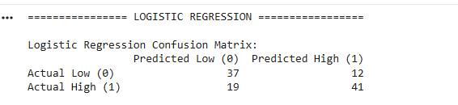
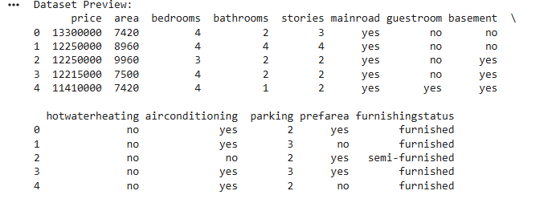
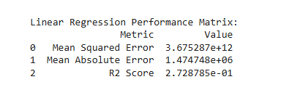
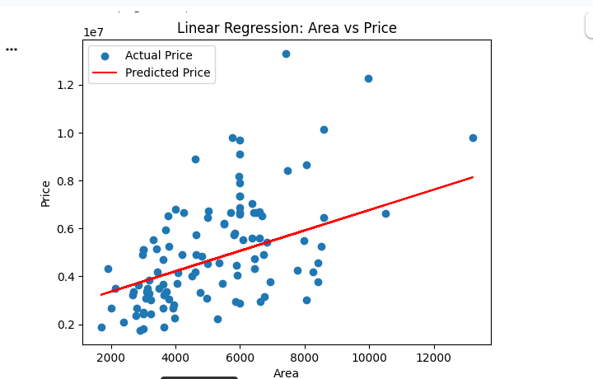
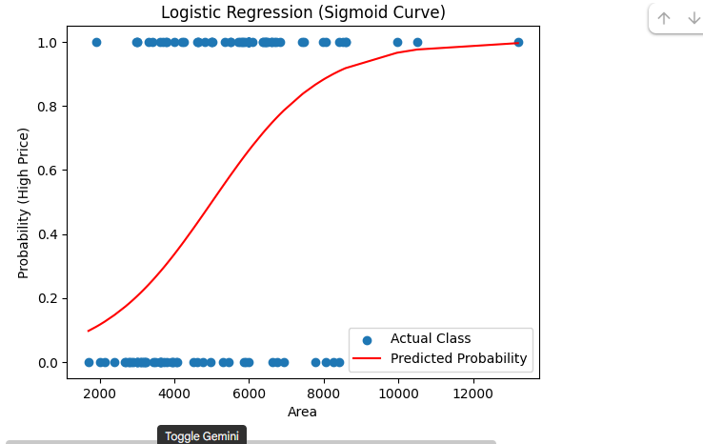

Conclusion:
- Linear Regression successfully predicted the continuous house prices, and its performance was evaluated using MSE, MAE, and R².
- Logistic Regression effectively classified houses into High Price and Low Price categories, evaluated using confusion matrix and performance metrics.
- Both models are useful:
  - Linear Regression → for price prediction
  - Logistic Regression → for categorical classification (High/Low Price)
- Visualization clearly shows:
  - Linear Regression → straight line
  - Logistic Regression → S-shaped sigmoid probability curve
- Using the same dataset for both regression types demonstrates the difference between regression and classification tasks

